**Deployment Document for Solution Setup**

**Project Title:** Solution Setup

**Date:** 20/06/2024

**Developer by:**

**Description:**

The Smartmesher Tool tessellate the selected object. First, the user must select the object and provide an appropriate name. Then, the tessellation process will commence.

**File we Use**

* SmartbitMesher.dll
* Smartbitmesher.dat
* Log(Folder)
* Text Folder

1. ui_content.txt
2. toolkitribbonui.rbn
3. resource Folder

1. smartbit_mesasurement.res

**Package Contents**

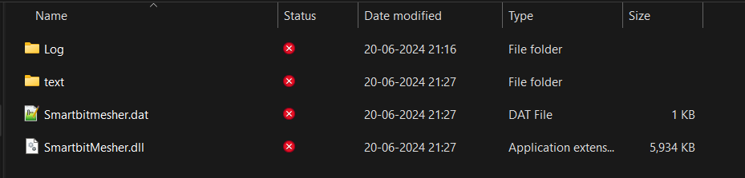

We can save this package Folder in any Location.

**Dat File**

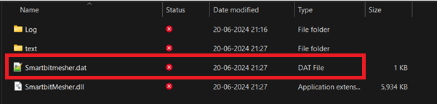

Once you open the .dat File. There you see the input names (NAME, EXEC_FILE, TEXT_DIR, STARTUP, END).



**NAME**

* We can modify the names as per our wish.

**EXEC_FILE**

* Please copy the .dll path and paste it next to the EXEC_FILE.

**TEXT_DIR**

* Please copy the text folder path and paste it next to the TEXT_DIR.

**STARTUP**

* Don’t Change it, just let it be.

**END**

* End Indication, no need to add anything.

**Log**

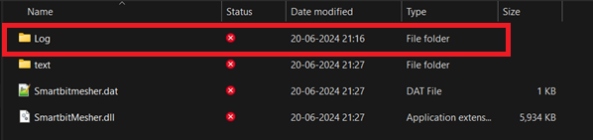

Here, we must create a Log Folder, which should be created only in the .dll path. the log file will be saved in .txt format.

**Text Folder**

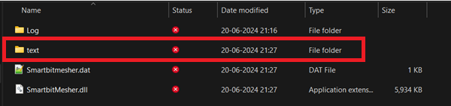

Once you open this text folder, you will find some files and folders. These files should not be moved from their original location and their names should not be changed.

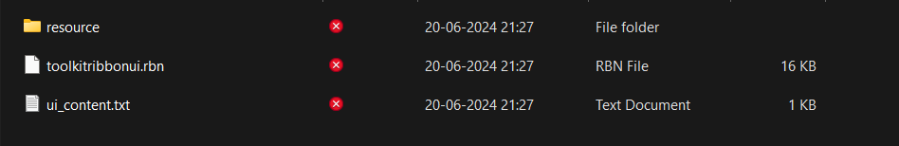

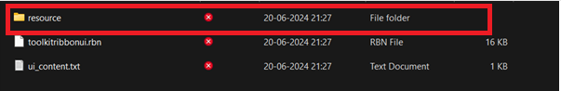

If you open this resource folder, you will find the file name called smartbit_measurement.res(UI File).



**Instant Start (Application)**

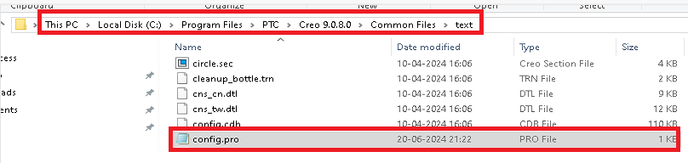

Go to the marked location, search for **config.pro**, and open that file in Notepad.

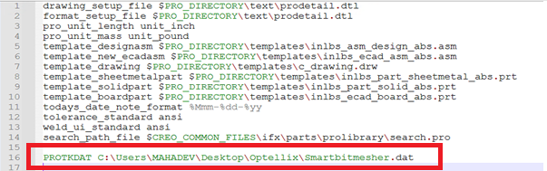

Type **PROTKDAT** and copy the .dat file path, then save. This line should be located on the last line of the file. This process will help us register the application immediately once Creo is launched.